

**Technical Manual**Version 4.0

Isabelle LECOMTE

November 2017

# Hi-sAFe overview

Hi-sAFe is a dynamic generic model simulating interactions between plants (trees and crops) in 3 dimensions, which account classical balance of materials and energy (water, nitrogen, light).

The Hi-sAFe model results from the coupling on the Capsis platform (Coligny, Ancelin et al., 2003) of a tree model and a crop model, through competition modules.

Capsis is portable software, written in Java, freely available under a GNU license (<http://capsis.cirad.fr/capsis/home>). Capsis project aims at integrating several types of forest growth and dynamic models and providing forest management tools to establish and compare different silviculture scenarios.

The tree model and the competition modules were designed and compiled in Java by the SAFE project team ([http://www1.montpellier.inra.fr/safe/).](http://www1.montpellier.inra.fr/safe/).%20) Six main modules have been specifically developed:

* Phenology
* 3D Light interception
* Water demand calculation
* C allocation (branch, foliage, trunk, stem, stump, roots, labile)
* Fine root growth
* Coarse root topology growth

**STICS** (Brisson et al, 2001) is the crop model embedded in Hi-sAFe. It has been developed in Fortran at INRA-Avignon (France) since 1996. It simulates crop growth as well as soil water and nitrogen balances driven by daily climatic data. Coupling Hi-sAFe with STICS has been realised with **JNA library**.

Water and nitrogen repartition module between trees and crop have also be specially designed for HisAFe in JAVA.

# Hi-sAFe scene

Agroforestry projects take place at a variety of scales, but the Hi-sAFe belowground modules operate at relatively small horizontal and vertical scales, over which local conditions can vary significantly. The following diagrams describe the process by which we move from the field scale through to the soil scale at which the Hi-sAFe belowground modules operate.



Figure : Spatial resolution – from the field scale to the voxel scale

The Hi-sAFe model simulates the evolution in a daily time step of a three-dimensional agroforestry scene. The scene, of fixed size, is divided into square cells (generally 1 m²) on which are distributed trees or crops (or bare soil). The growth of the trees is managed by Hi-sAFe, and each culture cell is simulated by a parallel execution of STICS crop model. Each culture cell develops independently of each other, depending on its interaction with the trees: light interception, rain interception, water and nitrogen competition.

A toric symmetry is applied in order to represent the scene in the middle of an agroforestry stand consisting of several identical interacting scenes, thus eliminating artificial edge effects.

Soil spatial resolution is not only based on structural characteristics, but also on a maximum thickness of soil suitable for the water extraction and the cellular automata module for tree root growth: the voxels. The voxels maximum size is fixed but in order to repect layers soil characteristics, some voxels can be smaller.

STICS crop model run with soil pedologic layers divided in 1cm minicouches. Every day STICS mini-couches will be agregated in Hi-sAFe voxel to import water and nitrogen balance executed in STICS model.



Figure : Definition of terms used in modules describing soil processes

# Hi-sAFe loop

In batch mode, Hi-sAFe simulations are managed by the simulation file (*.sim)

In this file the user give le plot file name (*.pld), the climat file name (*.wth), the number of simulation and the crop rotation design (*.plt and *.itk).

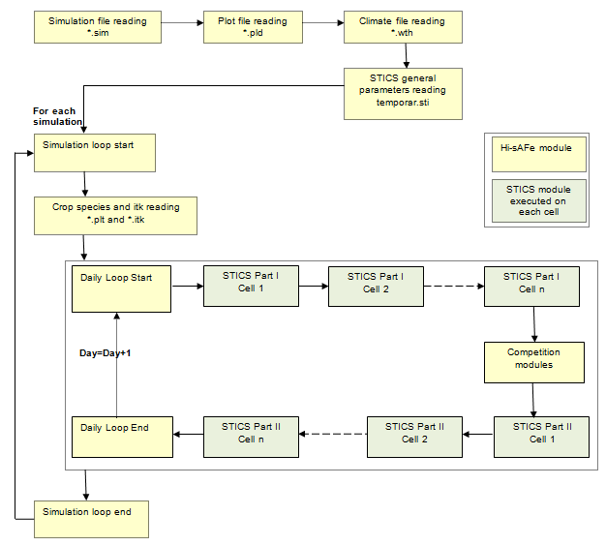

Figure : Hi-sAFe simulation loop (in batch mode)

At daily time step, interaction between tree model and crop model can be resumed like this:

1. Hi-sAFe provide light and rain incided on each cell of crop (climatic enties less tree interception)
2. Stics provide crop water and nitrogen demand
3. Hi-sAFe provide tree and crop water and nitrogen extraction in each mini-couche
4. Stics provide new water and nitrogen balance in the soil

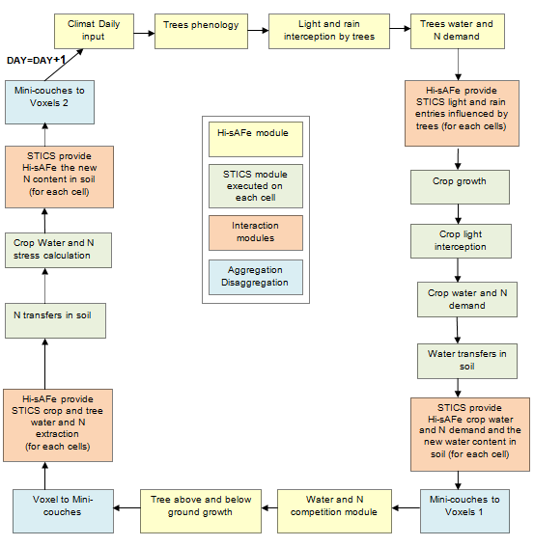

Figure : Hi-sAFe daily loop

3 modules have been developped in Hi-sAFE for

1. Converting voxels to mini-couches (desagregation) for tree water and nitrogen extraction and for crop water and nitrogen extraction after water and nitrogen compition module execution.
2. Converting mini-couches to voxels (agregation) for soil evaporation, water content, nitrogen concentration (no3 and nh4) and crop root density after crop growth and water transferts calcultation in soil.
3. Converting mini-couches to voxels (agregation) for soil nitrogen concentration (no3 and nh4) after N transfert in soil

# Details about coupling with STICS

## Technical solution

Java Native Access (J.N.A) library allows linking Java code with any other native language called C, C ++, Assembler, Fortran etc... STICS Fortran code has been compiled as .dll (windows) or .so (Linux) or .DyLib (MacOS) and then placed in a specific directory of CAPSIS

* Capsis4/ext/Windows for 32 bits windows PC
* Capsis4/ext/Windows64 for 64 bits windows PC
* Capsis4/ext/Linux for 32 bits linux PC
* Capsis4/ext/Linux64 for 32 bits linux PC
* Capsis4/ext/MacosX for Mac OS PC

The memory space between Java and Fortran is automatically shared. Thus, a Java object can be used in the Fortran code without copying the datasets under the condition that it is described exactly in the same way on both sides: fields of the same types and of the same lengths organized in the same order. Then, for each object in STICS, a mirror object has been created in Hi-sAFe.

|  |  |  |
| --- | --- | --- |
| **STICS objet** | **Description** | **Hi-sAFe object** |
| Parametre_generaux | General parameters | SafeSticsParameters |
| Stics_transit | Transition parameters | SafeSticsTransit |
| Station | Climatic station parameters | SafeSticsStation |
| Climat | Weather data | SafeSticsClimat |
| Sol | Soil description and data | SafeSticsSoil |
| Plante | Plant parameters and data | SafeSticsCrop |
| Itineraire_technique | Plant technical interventions data | SafeSticsItk |
| Stics_commun | Stics commun data | SafeSticsCommun |

Table : Object name mapping between STICS and Hi-sAFe

Entry points in STICS are methods called from Hi-sAFe model via JNA library process. All these methods are described in **SafeTestJNA** class in Hi-sAFe.

|  |  |
| --- | --- |
| **Method name** | **Description** |
| verifParam | General parameters initialisation and verification |
| verifPlant | Plant parameters initialisation and verification |
| initClimat | Climatic data initialisation and verification |
| initBoucleAnnuelle | Initialisation of year loop |
| boucleJour1 | Daily loop part I |
| boucleJour2 | Daily loop part II |
| finBoucleAnnuelle | End of year loop |

Table : STICS entry points in Hi-sAFe

## Stics adaptation

The idea was to leave the code of STICS relatively intact so that it could benefit from future versions, but it has appeared over time that to satisfy the specifications of Hi-sAFe, this code is finally deeply reworked. The changes made are justified by four main objectives:

1. Suppression of parameters files reading
2. Modifying annuel and daily loop
3. Insert tree interaction (light, water and nitrogen)

STICS code modification is described in detail in this document: livrable-12 Couplage nouvelle version de STICS.

### Supression of parameters files reading

All input and parameters files reading are done in Hi-sAFe. All reading methods have been disconnected from STICS initialisation program (but not removed from the STICS code source).

STICS is designed to link several years of simulations with different crops if needed. The technical solution choosen by STICS team is to store usefull output data at the end of a simulation in a text file and to read it as entry for the next year. We have decided to remove this text file (call recup.tmp) to replace it by memory storage in a Hi-sAFe object: **SafeSticsReinit**. This object contains all soil variables needed to link 2 simulations..

|  |  |  |
| --- | --- | --- |
| **STICS oject** | **Fortran disconnected method** | **JAVA replacing method or object** |
| General parameters | Lecture_Parametres_V6 | SafeSticsParamFormat.load |
| Soil parameters | Sol_lecture_V6 | SafeInventory.load |
| Climate | Climat_lire_fichier | SafeClimatFormat.load |
| Plant parameters | Plante_lecture-V6 | SafeSticsCropFormat.load |
| Plant itk | ITK_lecture_V6 | SafeSticsItkFormat.load |
| Recup.tmp (text file) | Lecture_DonneesCyclePrecedent  Ecriture_DonneesFinDeCycle | SafeSticsReinit |

Table : List of STICS reading method

### Modifying annual and daily loop

Hi-sAFe operates on a daily time step and therefore must control the execution of STICS for the same time step. STICS also runs on a daily time step, but its execution is planned with an uninterrupted annual loop launched either from a graphical interface allowing the entry of the simulation options, or in BATCH mode thanks to a file containing these same options of simulations. The annual STICS loop has therefore been removed in order to make possible a day-to-day execution, with all simulation options managed in Hi-sAFe (start and end dates, number of simulation days, choice of climate file, species, and technical itineraries). The daily loop was also cut in 2 parts to allow the introduction of the interaction with the trees in Hi-sAFe.

|  |  |
| --- | --- |
| **STICS method** | **Description** |
| climatSousAbri | calculate climate under shelter |
| photpd | calculates daily daylength and photoperiod |
| laidev | leaf area growth |
| croissance | crop growth simulation |
| detassement | Soil tillage implement |
| decisionsemis | calculation of the sowing date |
| decisionrecolte | calculation of the decision of harvest |
| tassesemisrecolte | compaction of the soil |
| apports | Water and fertilisation supplies |
| etatsurf | interception of water by mulch |
| volatorg | Ammonia volatilization |
| mineral | Calculation of nitrification, OM decomposition and N mineralization-immobilization |
| nitrif | Calculation of nitrification |
| denit | Calculation of denitrification |
| besoinsEnEauDeLaPlante | potential evaporation of the soil and maximum plant transpiration calculation |
| offrnodu | nitrogen fixation by legumes calculation |
| bNpl | crop N demand calculation |
| lixiv | water and nitrate transfers in soil |

Table : List of STICS methods (daily loop part I)

|  |  |
| --- | --- |
| **STICS method** | **Description** |
| transpi | Tranpiration of the crop calculation |
| offreN | Maximum amount of mineral N that the soil can deliver |
| absoN | The actual N uptake calculation |
| majNsol | Updates the elementary layer nitrogen and ammonium contents |
| stressEau | Water stress indices calculation |
| stressN | Nitrogen deficiency calculation |
| Ngrain | Biochemical composition of the harvested organ calculation |
| excesdeau | Waterlogging and corresponding stress indices calculation |
| caltcult | Crop temperature calculation |
| tempsol | Soil temperature calculation |
| humcouv | Daily average of the canopy moisture calculation |
| photpd | Current photoperiod calculation |
| humheure | Hourly reconstitution of microclimate state variables |
| cumAOetAS | Combines the state variables shade and sun |
| GestionDesCoupes | Cutting process for perennial crops |
| dynamictalle | Simulation de la dynamique des talles d'un couvert |

Table : List of STICS method (daily loop part II)

### Insert tree interaction

Tree interacts with crop because of:

* Light interception
* Rain interception
* ETP modification
* Water and nitrogen extraction

Some interaction are simulated by updating directly some variable in STICS object (JAVA code):

|  |  |  |
| --- | --- | --- |
| **STICS variable** | **Description** | **Unit** |
| sticsClimat.trg | Global radiation (climat input) – radiation intercepted by trees | MJ m-2 |
| sticsClimat.trr | Rain (climat input) – rain intercepted by trees | mm |
| sticsClimat.tetp | ETP (climat input) influenced by trees | mm |
| sticsCrop.epz | Crop water uptake | mm |
| sticsCrop.absz | Crop nitrogen uptake | Kg ha-1 |

Other interactions have been introducted with new parameters in STICS methods (fortran code):

|  |  |  |  |
| --- | --- | --- | --- |
| **STICS method** | **New parameter** | **Description** | **Unit** |
| **Stics_Jour2** : daily loop II  **Transpi** : crop water uptake calculation  **absoN** : crop nitrogen utake calculation  **stressEau** : crop water stress calculation  **stressN** : crop nitrogen stress calculation | hisafeInfluence | Indicates if water and nitrogen extraction is computed by Hisafe | true/false |
| **Stics_Jour2** : daily loop II  **Calrnet**: net radiation calculation  **Caltcult**: crop temperature calculation | cellvisibleSky | Percentage of visible sky on the crop | % |
| **Stics_Jour2**: daily loop II  **Calrnet**: net radiation calculation  **Caltcult**: crop temperature calculation | cellTrg | Percentage of global radiation on the crop | % |

Other interactions have been introducted with new variables in STICS object (fortran code):

|  |  |  |  |
| --- | --- | --- | --- |
| **STICS new variable** | **Description** | **STICS method using this variable** | **Unit** |
| sticsCommun.treeWaterUptake | Tree water uptake | **Lixiv** : water transferts in soil | mm |
| sticsCommun.treeNitrogenUptake | Tree nitrogen uptake | **majNsol** :nitrogen extraction in soil | kg.ha-1 |

## STICS and HI-sAFe soil discretisation difference

Soil in Hi-sAFe is divided in pedologic layers (5 max) sub-divided in voxels of variable thickness. Soil condition in each voxel is homogenous, it means that all state variables (water content, nitrogen concentration, plant root density etc..) have the same value. STICS soil is composed of (1000 max) mini layers of 1cm and water and nitrogen budget is done on these mini-layers.



Figure : Soil discretisation difference between Hi-sAFe and in STICS

Specific program have been written to disaggregate in one hand some Hi-sAFe results from voxel to mini-layers and to aggregate STICS results from mini-layers to voxels in another hand.

**Method SafeCell.miniCouchesToVoxelsAfterStics1**

Agregation of STICS minicouches values in HISAFE voxels after STICS PART 1.

STICS variables treated are:

|  |  |  |
| --- | --- | --- |
| **Stics variable** | **Description** | **Hi-sAFe variables** |
| sticsCommun.HUR | Soil humidity in % | Voxel.Theta |
| sticsCommun.esz | Soil evaporation in mm | Voxel.evaporation |
| sticsCommun.tsol | Soil temperature in °C | Voxel.soilTemprature |
| sticsSoil.nit | Soil no3 kg N ha-1 | Voxel.no3Stock |
| sticsSoil.amm | Soil nh4 kg N ha-1 | Voxel.nh4Stock |

**Method SafeCell.miniCouchesToVoxelsAfterStics2**

Agregation of STICS minicouches values in HISAFE voxels after STICS PART 2.

STICS variables treated are:

|  |  |  |
| --- | --- | --- |
| **Stics variable** | **Description** | **Hi-sAFe variables** |
| sticsSoil.nit | Soil no3 kg N ha-1 | Voxel.no3Stock |
| sticsSoil.amm | Soil nh4 kg N ha-1 | Voxel.nh4Stock |

**Method SafeCell.voxelsToMiniCouches**

Desagregation of HISAFE voxels in STICS minicouches values in after water and nitrogen repartition.

Hi-sAFe variables treated are:

|  |  |  |
| --- | --- | --- |
| **Hi-sAFe variable** | **Description** | **STICS variables** |
| voxel.treeWaterUptake | Tree water uptake in liters | sticsCommun.treeWaterUptake |
| voxel.treeNitrogenUptake | Tree nitrogen uptake in kg N ha-1 | sticsCommun.treeWaterUptake |
| voxel.cropWaterUptake | Crop water uptake in liters | sticsCrop.epz |
| voxel.cropNitrogenUptake | Crop nitrogen uptake in kg N ha-1 | sticsCommun.absz |

# Hi-sAFe architecture

## Capsis main classes

Capsis has kernel/modules architecture with a separated pilot. Main feature is the possibility to specialise in different modules, all generic classes provided by the kernel.

This organisation requires an oriented object language to take advantages of heritage mechanism.



Figure 6 : Hi-sAFe main classes diagramme

|  |  |
| --- | --- |
| **Class** | **Description** |
| Session | Class supporting the user working session that can be entirely saved on disk. One session can include different scenarios |
| Scenario | Class supporting one running simulation: model choice, duration of simulation, collection of steps etc... |
| Step | Visible step of the simulation depending of the modeller choice (can be different of computing step).  All states variables of the model can be inspected step by step with graphical or text viewers. |
| Gmodel | Principal model class containing the generic execution loop for initialisation and evolution processing. |
| GStand | Generic stand composed of a collection of trees |
| GTree | Contains generic state variables relative to an individual tree (age, height, dbh) |
| GPlot | Generic spatial attributes of the desegregation of the stand |
| GCell | Generic cells attributes of the plot (shape: any polygon is possible) |

Detailed CAPSIS documentation can be downloaded from <http://capsis.cirad.fr/capsis/documentation>

## Hi-sAFe main classes

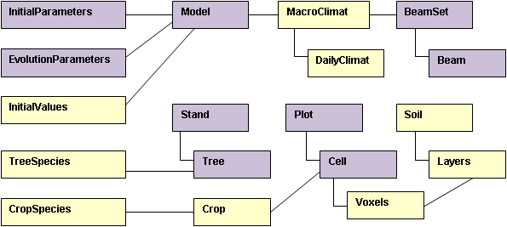

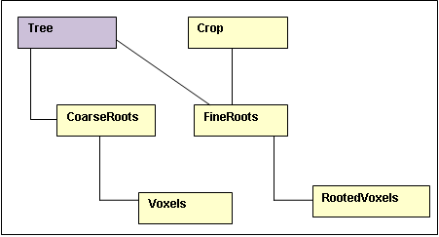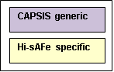

Figure 7 : Hi-sAFe main classes diagramme

|  |  |  |
| --- | --- | --- |
| **Class** | **Description** | **CAPSIS generic class** |
| SafeBeam | Beam (direct of diffuse) composing a BeamSet | Gbeam |
| SafeBeamSet | Beam set for light processes. | GBeamSet |
| SafeCell | Square cells composing the plot. | SquareCell |
| SafeCrop | The crop on each cell |  |
| SafeCropSpecies | Parameters for crop species (one record by species). |  |
| SafeDailyClimat | Daily macro-climate input (rain, temperatures, solar radiation...) during one simulation. |  |
| SafeCoarseRoot | Objet for tree coarse root topology |  |
| SafeFineRoot | Information about fine roots (tree or crop) |  |
| SafeEvolutionParameters | Information useful for launching each simulation (dates, crops species, input file names) | GSettings |
| SafeInitialParameters |  |  |
| SafeInitialValues | Initial values (soil and trees) of the running simulation |  |
| SafeLayer | Pedological layers of the soil (5 Max) |  |
| SafeMacroClimate | Macro-climate data |  |
| SafeModel | Principal class containing the execution loop for initialisation and evolution processing | GModel |
| SafePlot | Spatial desegregation of the stand (rectangular grid composed of square cells) | RectangularPlot |
| SafeSoil | The soil (general data) |  |
| SafeStand | The modelled stand as a collection of trees | GTCStand |
| SafeTree | Each tree composing the stand | GMaddTree |
| SafeTreeSpecies | Parameters for tree species (one record by species). |  |
| SafeVoxel | 3D volume of soil resulting from the intersection of a cell column and a soil layer. |  |
| SafeVoxelRoot | Object linking a fineRoot object with relative rooted voxels. |  |

## STICS classes

These classes are used to link Hi-sAFE and STICS. Each classe is a mirror of a STICS object in the fortran code.

|  |  |  |
| --- | --- | --- |
| **Hi-sAFe class** | **STICS class** | **Description** |
| SafeSticsClimat | Climat | Objet for storing STICS climat data |
| SafeSticsCommun | Stics_Communs | Objet for storing STICS commun data |
| SafeSticsCrop | Plante | Objet for storing STICS crop data |
| SafeSticsItk | ITK | Objet for storing STICS itk data |
| SafeSticsParameters | Parametres_Generaux | Objet for storing STICS general parameters data |
| SafeSticsSoil | Sol | Objet for storing STICS soil data |
| SafeSticsStation | Station | Objet for storing STICS station data |
| SafeSticsTransit | Stics_Transit | Objet for storing STICS transit parameters data |
| SafeSticsReinit | Replace file recup.tmp | Objet for storing STICS data for linking simulations sequences |